**SELECTION SORT**

#include <bits/stdc++.h>

#include <chrono>

using namespace std;

int main() {

cout << "Enter the no. of elements in the array: ";

int n = 10000;

int lb = 0, ub = 100;

int a[n];

for (int i = 0; i < n; i++)

a[i] = (rand() % (ub - lb + 1)) + lb;

auto start = chrono::high_resolution_clock::now();

for(int i = 0; i < n; ++i)

{

int min = 1e5, m_index = i;

for(int j = i; j < n; ++j)

{

if(min > a[j])

{

min = a[j];

m_index = j;

}

}

swap(a[i], a[m_index]);

}

auto stop = chrono::high_resolution_clock::now();

auto duration = chrono::duration_cast<chrono::microseconds>(stop - start);

cout << "Sorted elements: ";

//for(int i = 0; i < n; ++i)cout << a[i] << " ";

cout << "\nTime taken: " << duration.count() << " microseconds";

return 0;

}

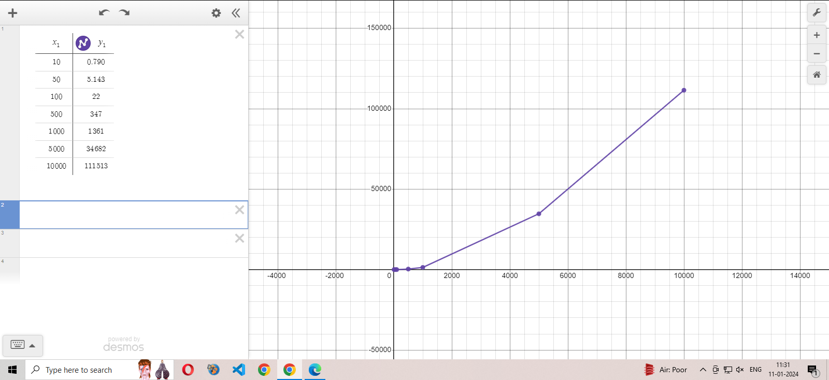

**INSERTION SORT**

#include <iostream>

#include <chrono>

using namespace std;

int main() {

int n = 10000;

int lb = 0, ub = 100;

int a[n];

for (int i = 0; i < n; i++)

a[i] = (rand() % (ub - lb + 1)) + lb;

auto start = chrono::high_resolution_clock::now();

for(int i = 1; i < n; ++i)

{

int k = a[i];

int j = i - 1;

while(j >= 0 && a[j] > k)

{

a[j + 1] = a[j];

j--;

}

a[j + 1] = k;

}

auto stop = chrono::high_resolution_clock::now();

auto duration = chrono::duration_cast<chrono::microseconds>(stop - start);

cout << "Sorted elements: ";

//for(int i = 0; i < n; ++i)cout << a[i] << " ";

cout << "\nTime taken: " << duration.count() << " microseconds";

return 0;

}

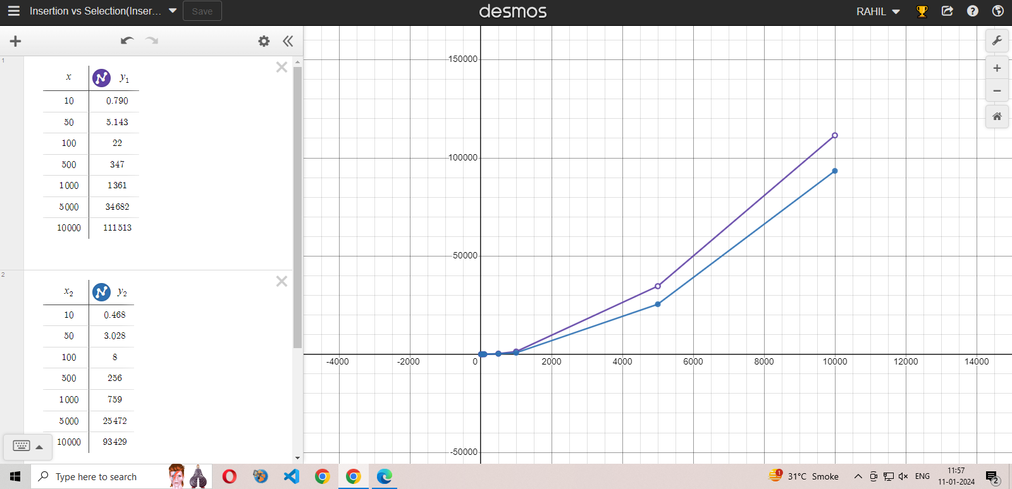

Blue wala is insertion.

